# 2, Thuc Hanh

## Lab1

sudo sysctl -w kernel.randomize_va_space=0

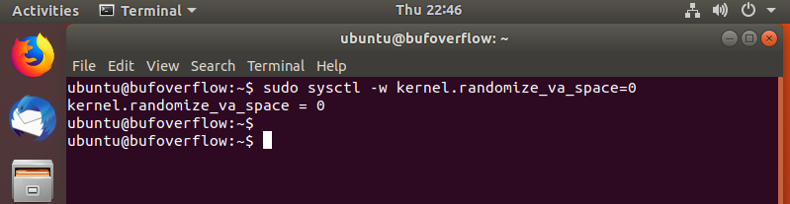

$ sudo su

# gcc -m32 -o stack -z execstack -fno-stack-protector stack.c

# chmod 4755 stack

# exit

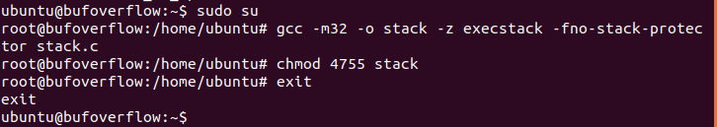

sudo nano exploit.c

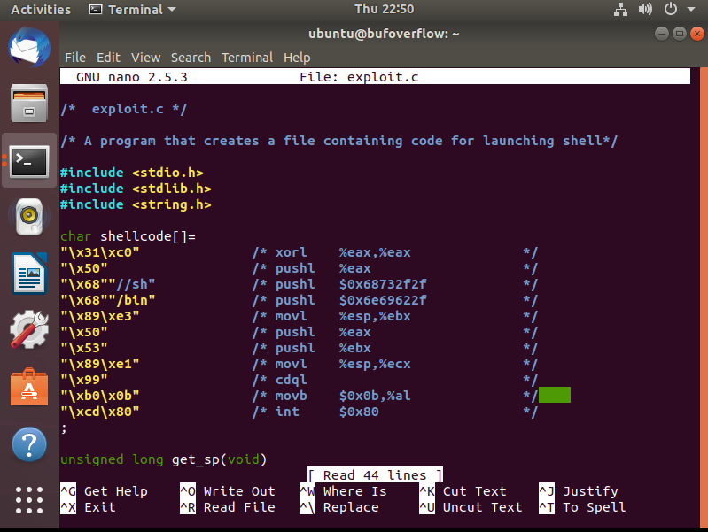

gdb --quiet stack

disassemble bof

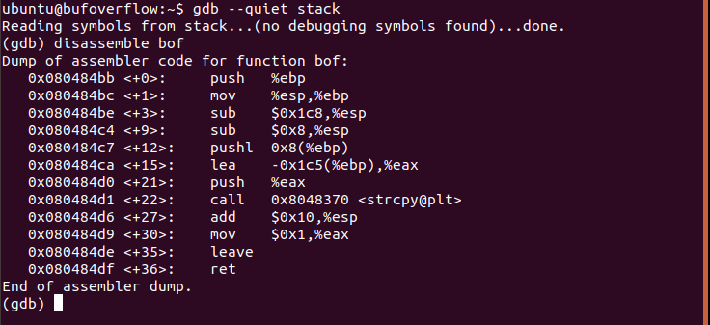

b* 0x080484ca

r

i r

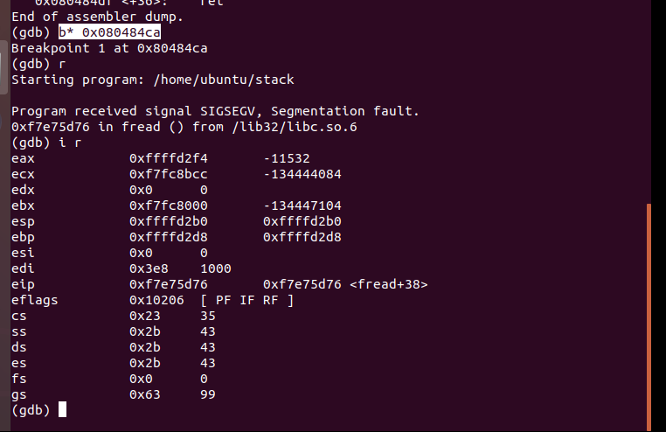

i r $ebp



sudo nano exploit.c

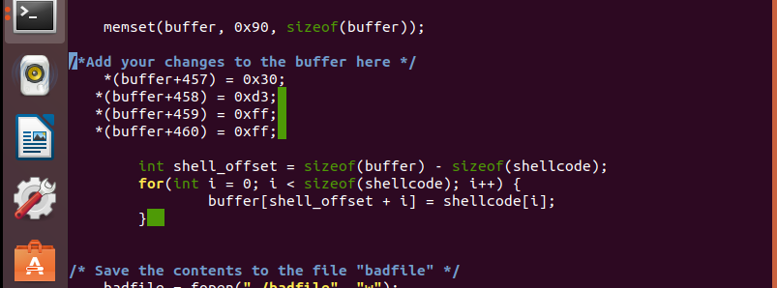

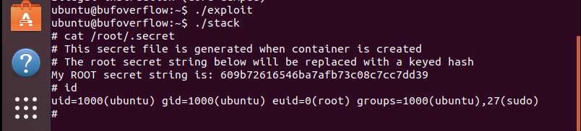

## Lab2

sudo /sbin/sysctl -w kernel.randomize_va_space=2

./whilebash.sh

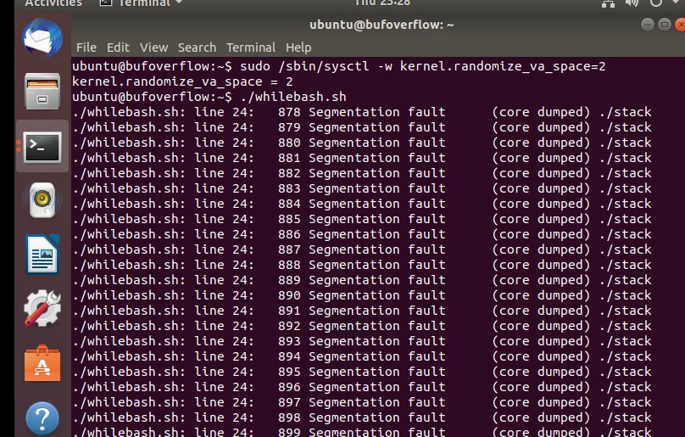

sudo /sbin/sysctl -w kernel.randomize_va_space=0

gcc -m32 -o stack -z execstack stack.c

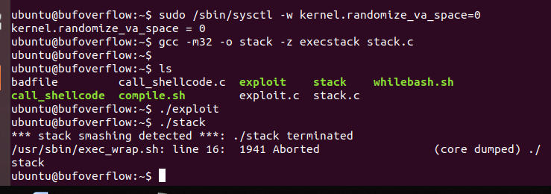

gcc -m32 -o stack -fno-stack-protector -z noexecstack stack.c

chmod 4755 stack

